These instructions are for the installation of the Samsung WiFi Speaker/Soundbar into the SmartThings platform. The associated device handler was designed and tested against the HW-MS650 Speaker/Soundbar; however, it will likely work with other Samsung WiFi Speaker/Soundbars as well as with other single Samsung MultiRoom Speakers.

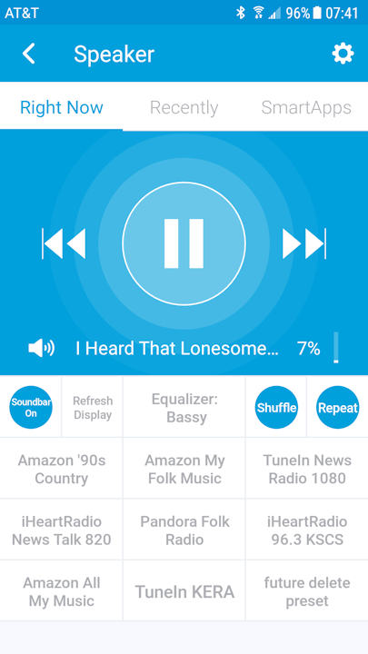

**INSTALLATION FILES**

DeviceHandlers directory

* “Samsung WiFi Speaker/Soundbar (Beta).groovy” – The device handler that will be installed.

Documentation Directory

* “Install - Samsung WiFi Speaker-Soundbar.pdf"
* “Users Guide - Samsung WiFi Speaker-Soundbar .pdf"

**PRE-REQUISITES**

- A compatible Samsung WiFi speaker already installed into the Samsung Multiroom application.

- You MUST know the IP address of your Speaker/Soundbar for this version.

- A Samsung SmartThings “Developer Tools” account.

- For Presets, set up of stations or playlists as follows:

1. Amazon Prime Playlist. Have the playlists installed in: “My Music” > “Playlists”.

2. TuneIn. Have the desired stations installed in “Following” and designated as PRESETS.

3. iHeartRadio. Have the desired stations installed in “Favorites”.

4. Pandora. Have created the desired stations.

**BASIC INSTALLATION STEPS - Index**

A. Assign static IP address for the Speaker/Soundbar.

B. Install the Device Handler into the SmartThings environment.

C. Install the devices in SmartThings.

D. Select the input source you desire.

E. Optional: Set the preset channels.

**A. ASSIGN STATIC IP ADDRESSES**

Assigning Static IP addresses is done through your router. It will vary from router to router. If you do not set a static IP address, you will have to re-enter the IP address if it changes during a router or Speaker/Soundbar reboot. (This is fairly infrequent.)

EXAMPLE:, for a TP-Link Archer 3150) the steps are:

a. Log in and go to the Advanced tab.

b. select "Network" - "DHCP Server" at the left sice.

c. Go to the Address Reservation section and select Add.

d. Fill in the MAC ADDRESS, IP, and Description.

e. Reboot the Router and check that IPs have not changed.

**B. INSTALL THE DEVICE HANDLERS ON SMARTTHINGS**

1. Log in to SmartThings IDE. (You may have to create an acccount.)

2. After log in, go to "My Locations" and select your current location.

3. Go to "My Device Handler" and select "+ Create New Device Handler".

3. Select the tab "From Code".

4. Open the file “Samsung WiFi Speaker (Beta).groovy” and copy the contents.

5. Past the contents into the the IDE window. Select "Create" at the bottom.

6. On the next page that opens, click “Publish”, then “For Me” near the top-right of the page.

**C. INSTALL THE ACTUAL DEVICES ON SMARTTHINGS**

1. Go to "My Devices" in IDE, click on New Device in the top right corner (you will repeat this step for each of the outlets you have)

o Name – Enter a model name. Free form. i.e. “Samsung HW MS650 Speaker/Soundbar

o Label - enter a label, this is what will show in the SmartThings app, (i.e., “Speaker/Soundbar”, "TV Speaker").

o Device Network Id - enter a unique ID (i.e., HWMS650 or the Device MAC address).

o Type - select the “Samsung WiFi Speaker/Soundbar” type from near the bottom of the drop-down).

o Version – Published.

o Location and Hub - select for your setup.

o Group - leave blank for now, you can assign to a room later through the app.

o Click Create

2. Open SmartThings on your smart phone and select your device. Go to the Settings page. (Alternately, this can be done on the IDE device page.)

a. Device IP. Enter the IP Address for your Speaker/Soundbar.

b. Select “Done” in the upper right corner

3. Test the functions of your device.

**D. Selecting Input Source**

1. Go to the options page (* at the upper right of the page).

2. Select the line titled “Speaker Source. This will cause a new display page: “Speaker Source”.

3. Select the Source you wish for your device. When you select the source, it will return to the options page.

4. Select Save. If there are no errors and you selected a valid source for your device, the device will update automatically. The top-right Tile below the music control window will show the current source.

**E. Adding Stations**

1. Assure that the desired stations are installed in the Multiroom App at the locations

a. Amazon Prime Playlist. Have the playlists installed in: “My Music” > “Playlists”.

b. TuneIn. Have the desired stations installed in “Following” and designated as PRESETS.

c. iHeartRadio. Have the desired stations installed in “Favorites”.

d. Pandora. Have created the desired stations.

e. Amazon Prime Stations. No action required.

2. Copy down the EXACT title of your station.

3. Open the device in the SmartThings app or in the “devices page” on the IDE.

a. For the app, go to the options page (* at the upper right of the page).

b. For the device page, go down to the “Preferences” section and select “edit”.

3. For each desired preset, enter:

a. Preset Player Name from the selection menu (app) or as text in the IDE. Play names are:

1) Amazon Station (Amazon Prime > Prime Stations)

2) Amazon Playlist (Amazon Prime > My Music > Playlists)

3) Tunein (TuneIn > Following)

4) iHeartRadio (iHeartRadio > Favorites)

5) Pandora.

b. Preset Station/Preset. The exact, full title of the preset station or playlist.

c. Preset Short Name. This is the display name at the bottom of the application. It can be anything, but long names will have smaller fonts on the display.

4. Select “Save” to save these preferences.

5. Test your presets. (SEE BELOW. There are some idiosyncracies.

**F. Implementation Notes**

1. When using the Multiroom app to start music, when entering the app, depress “Update Display”. This will update the interface for the chosen player.

2. Presets sometimes hangs (the command is not acted upon). Reason unknown. Try again after about 5 seconds.

3. Display of status is slow and sometimes SmartThings does not parse nor update the display. Use Update Display to force this action.

4. Music Player functionality depends upon the player. See below.



5. Music Play is generally available in all of the above. All functions are available for your local DLNA players identified in the Multiroom app. For HDMI, Bluetooth, Auxiliary, and HDMI(ARC)/Optical, the play/pause function does not work.